DATA VISUALIZATION PROJECT

Global Internet Users

Submitted by

Saurabh Pandey
(Name of student)

Registration No. 12017578

Programme and Section …K20PD………
Course Code ..........INT233....

Under the Guidance of

Tanima Thakur

Discipline of CSE/IT

Lovely School of Computer Science and Engineering

Lovely Professional University, Phagwara

CERTIFICATE

This is to certify that Saurabh Pandey (student’s name) bearing Registration no 12017578....... has completed ....INT233....... <Course Code> project titled, “Global Internet Users” under my guidance and supervision. To the best of my knowledge, the present work is the result of his/her original development, effort and study.

Signature and Name of the Supervisor
Designation of the Supervisor
School of …………Computer Science and Engineering…………………….
Lovely Professional University
Phagwara, Punjab.

Date: 10-04-2023

DECLARATION

I, .............Saurabh Pandey........, student of ..........Data Visualization INT233.................. (Program name) under CSE/IT Discipline at, Lovely Professional University, Punjab, hereby declare that all the information furnished in this project report is based on my own intensive work and is genuine.

Date: Signature
Registration No. ...........12017578................ Name of the student
Saurabh Pandey

INTRODUCTION
This report presents the data visualization of the Global Internet Users dataset, which was obtained from Kaggle. The dataset contains information on the number of internet users in different countries around the world, as well as their corresponding populations. The purpose of this report is to provide an insightful analysis of the dataset through various charts, graphs, and tables.

Source of Dataset
The dataset was collected from various sources, including the International Telecommunications Union (ITU) and the World Bank. It contains data on the number of internet users, population, and internet penetration rates for 217 countries, as well as data on income groups and regions.

Scope of the Analysis
This visualizations highlight the variations in internet usage across different regions and income groups. For instance, countries in North America and Europe have higher internet penetration rates compared to those in Africa and Asia. Similarly, high-income countries have higher internet penetration rates compared to low-income countries.

Analysis on dataset

From the visualizations, it is evident that there has been a steady increase in the number of internet users globally, with a particularly rapid growth rate in developing countries. The data also shows that there is a strong correlation between a country's population size and the number of internet users, as well as between a country's income level and internet penetration rate.
I-Top 20 countries with most No. of Internet users:
In this visualization we will analyses the top 20 countries most no of Internet users.
We use colored bar chart for this visualization by filtering top 20 countries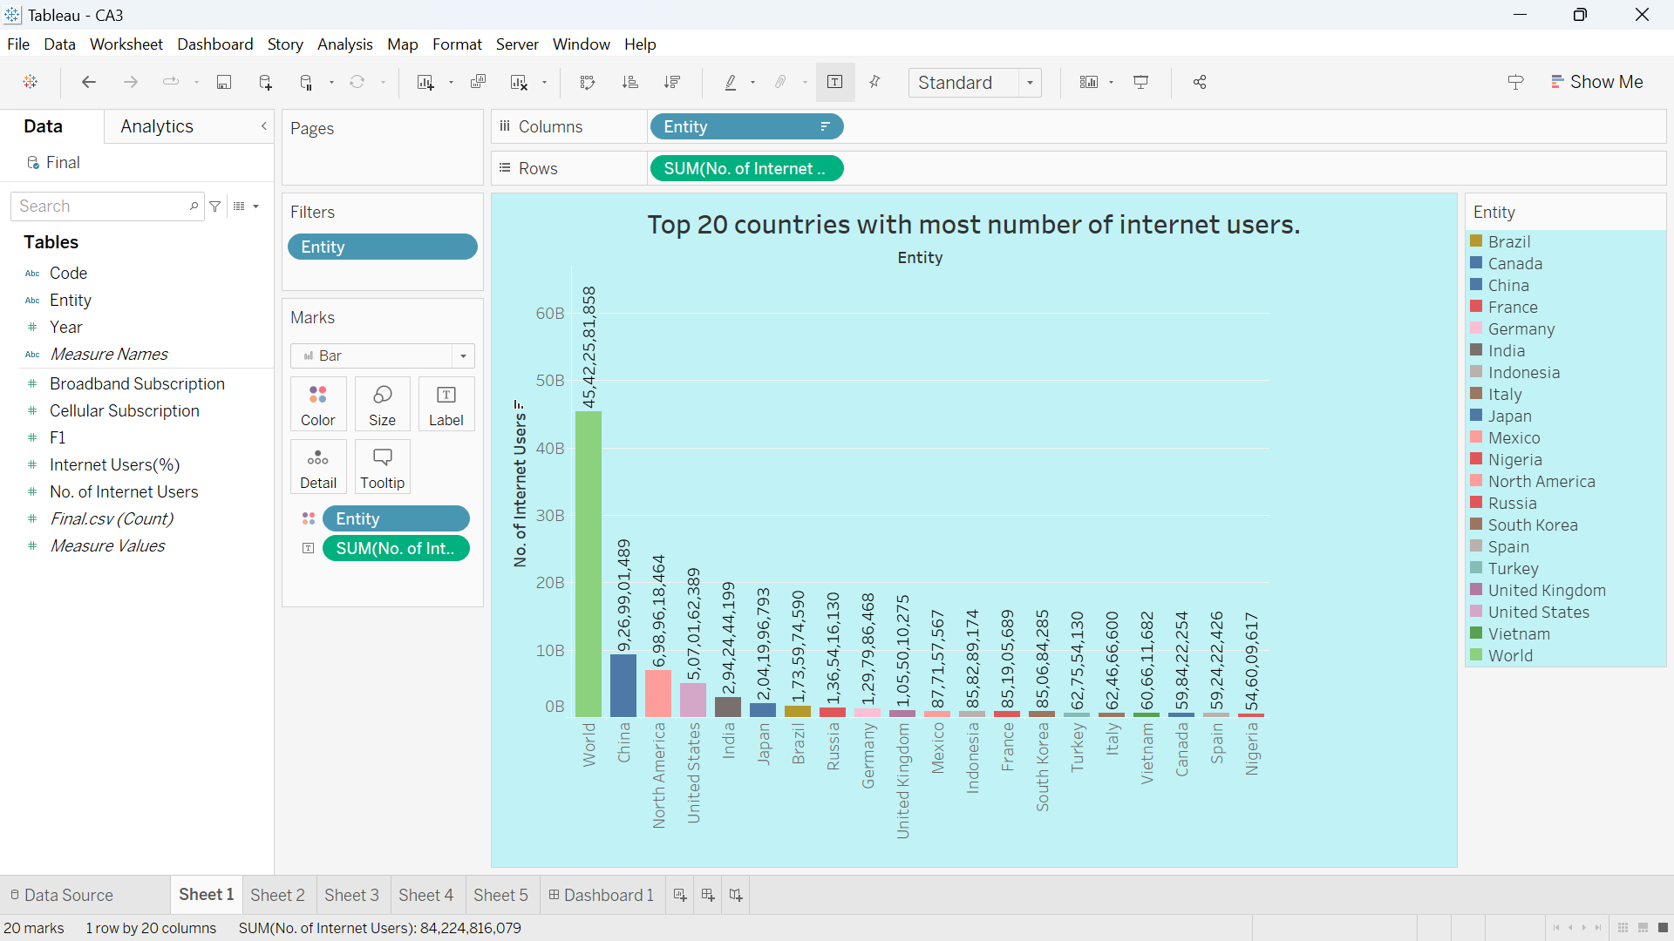

2- Top 20 countries with most no of cellular subscription.
In this visualization we will analyze top 10 countries with most no of cellular subscription.
We use horizontal bar chart in this wit top 10 filter.
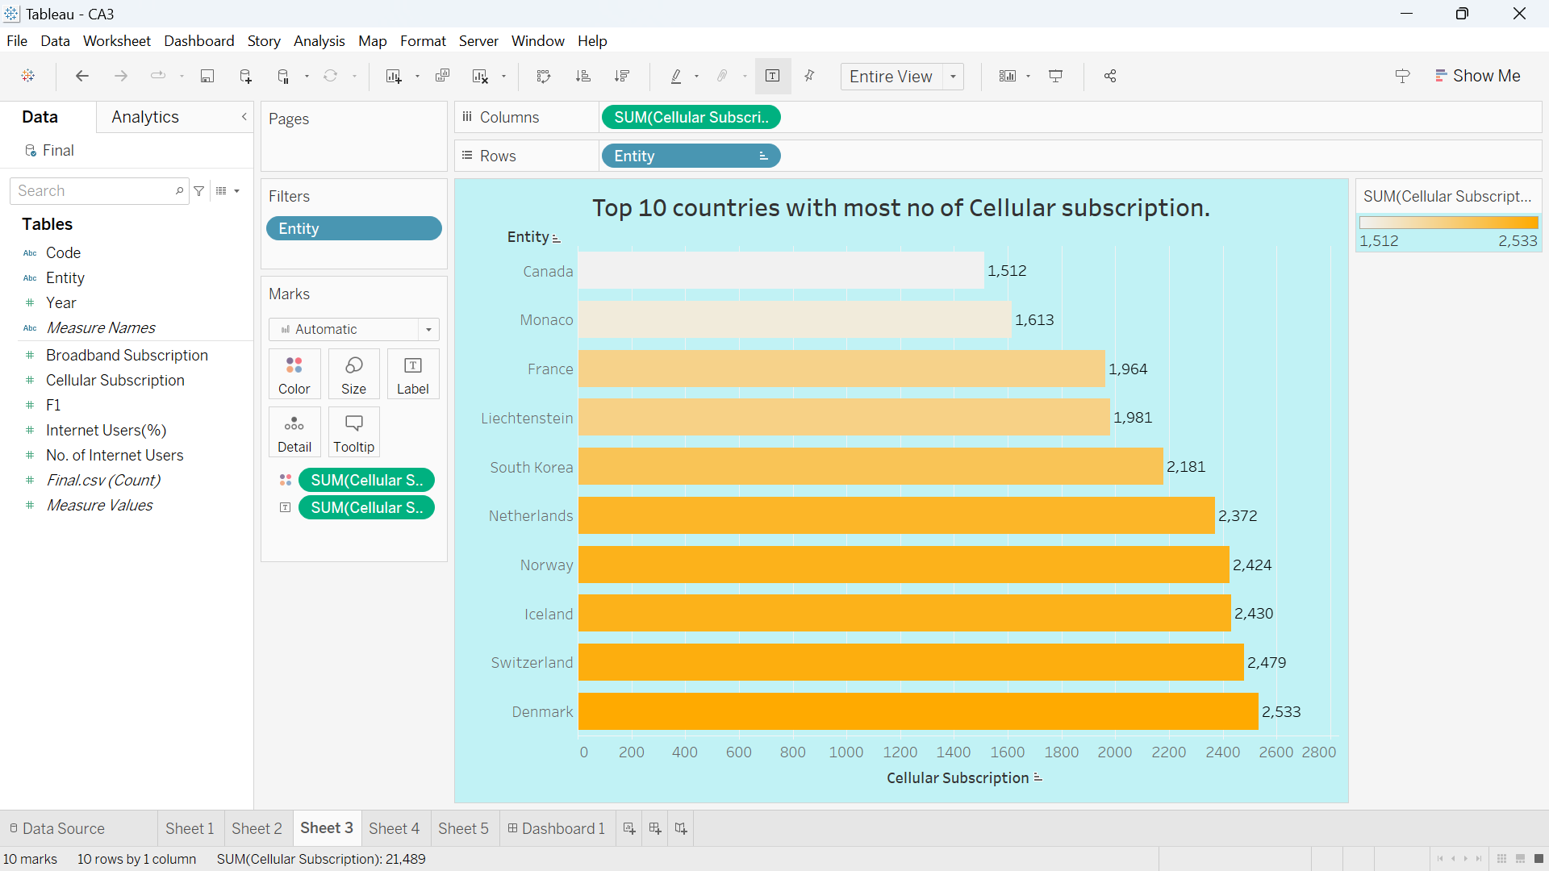
3- Percentage of Internet user each year.
In this visualization we will show that highest percentage of internet users is in 2017.and there so much hike in percentage of internet users by 2010.
We used Bubble chart for showing this analysis.
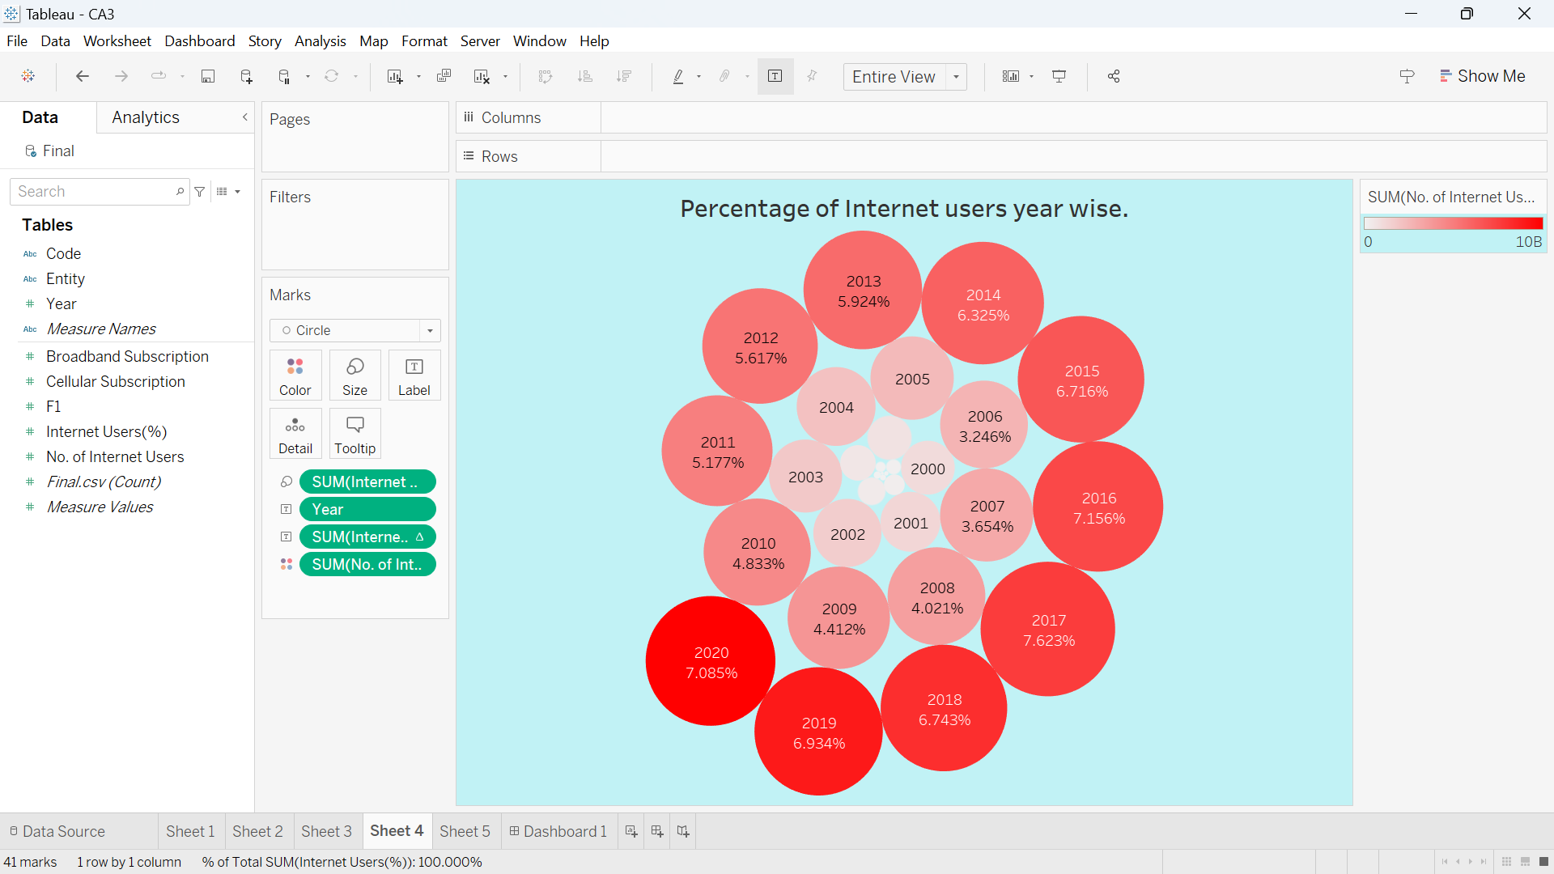
4- Top 10 countries with most no of broadband subscriptions.
In this visualization we will talk about top 10 countries with most no. of broadband subscription, we can clearly say that Monaco is with most no. of broadband subscription.
We used pie chart to show this with top 10 filter and showing the percentage by using quick table calculations.
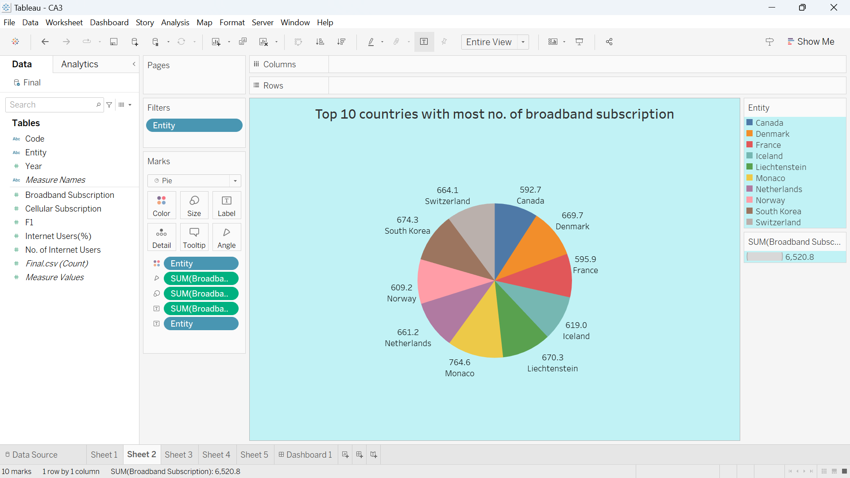

5- Most % of Internet users per year.
In this visualization we will show that most % of internet users per year, we can clearly see the hike from 2010 in each country and countries like India show exponential hike after 2013 onward.
We use Area chart with top 10 filters and using color option showing year wise internet users hike.

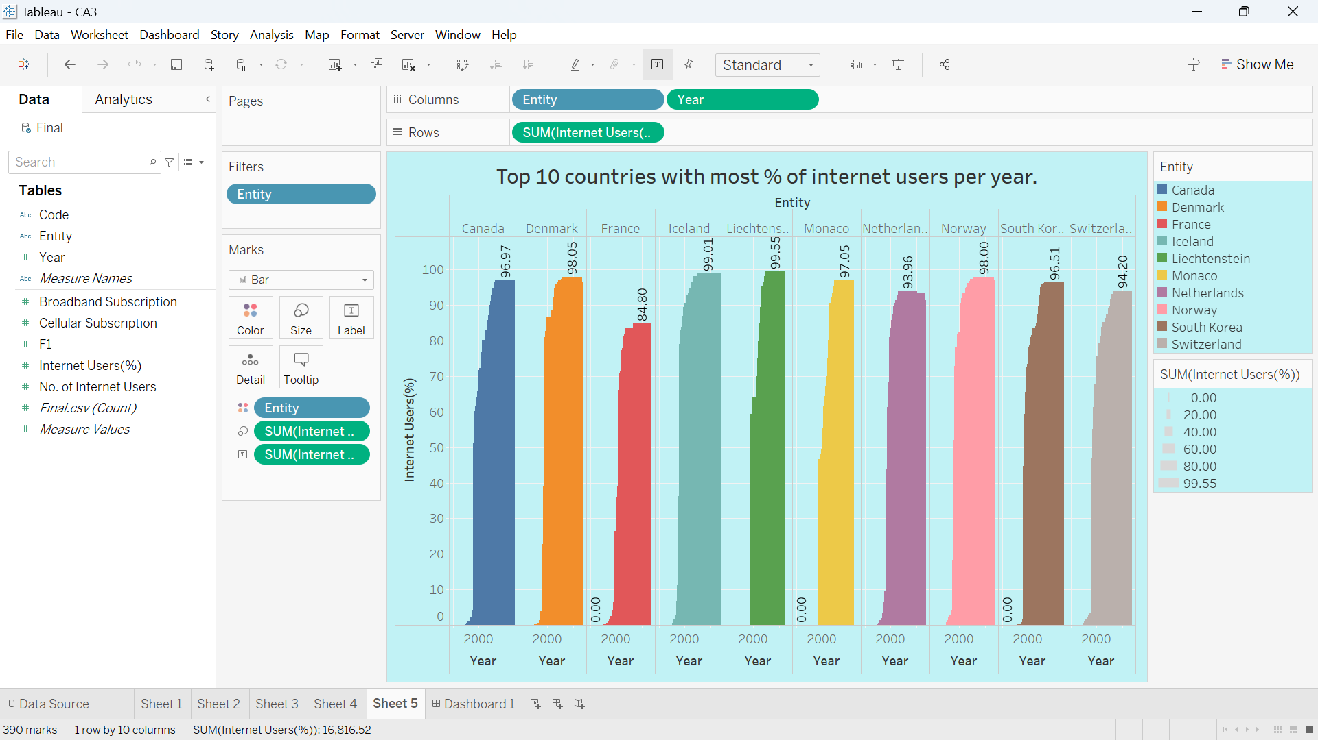

The Dashboard of Global Internet Users.
To better understand the data, several visualizations were created using Tableau software. The report includes a variety of visualizations, including filters various charts including bar charts. The visualizations highlight trends and patterns in the data and provide a clear representation of the internet usage across different countries.
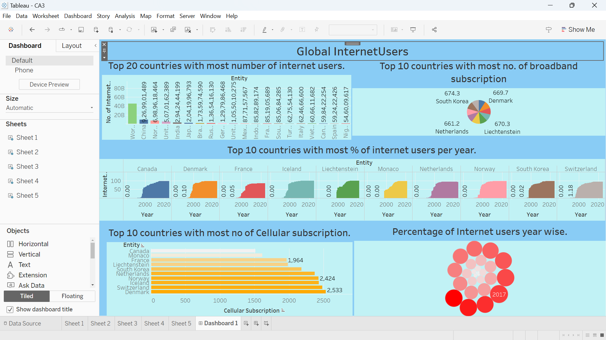
Conclusion:
In conclusion, the report provides a comprehensive analysis of the Global Internet Users dataset. The data visualizations highlight important trends and patterns in the data, and provide insights into the variations in internet usage across different countries, regions, and income groups. These findings can be useful for policymakers, businesses, and individuals seeking to understand the current state of internet usage and to identify opportunities for growth and development in the internet sector.

References:
Tableau Desktop
Kaggle

